On the GPIO bus, you will need to use the I2C.1 pins plus 3.3v power and ground. Note, you need a single pull up resistor of 83K or higher between the SCL and 3.3v and another one between SDA 3.3v. Here is the pin to cable layout:
- GPIO bus pin 5 is SDC -- yellow wire on dIMU cable
- GPIO bus pin 3 is SDA -- white wire on dIMU cable
- GPIO bus pin 1 is +3.3v -- red wire on dIMU cable
- GPIO bus pin 9 is ground -- black wire on dIMU cable

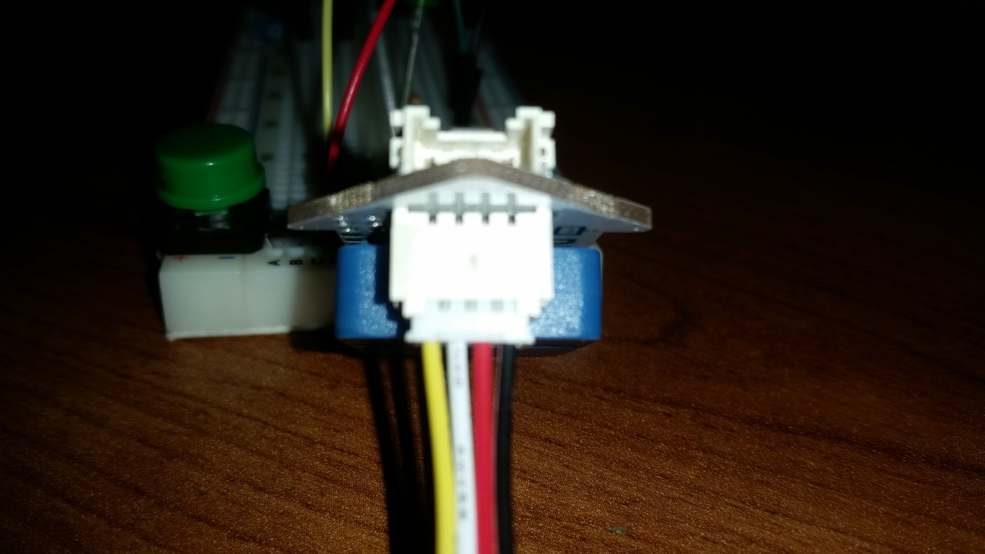
Here is a picture of the cable
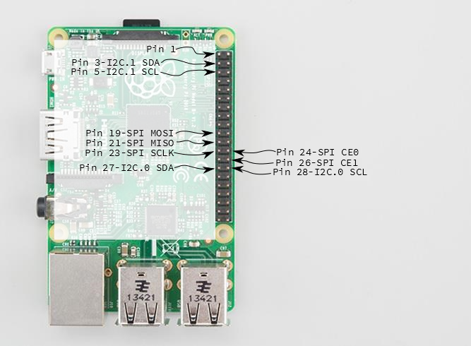
Here is a picture of the 40 pin connector

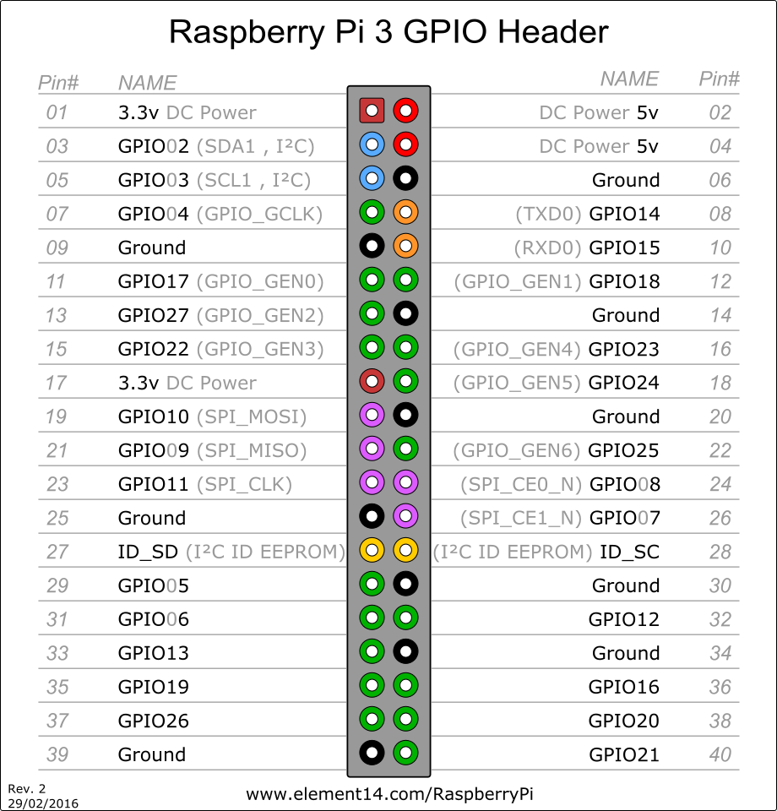
And here is the full pinout

